## Merchant

Demo date: Oct. 15, 2024  
Scoping start date: Oct 14, 2024

MSA Signature Date: Oct 16, 2024  
Onboarding Kick Off Date: Oct 21, 2024

[If Exists] Opt Out Date:  
Go Live Date: Nov 8, 2024

GTM POC: Nick  
Implementation POC: Ariel

ERP: QBO

Tax Integration: No Tax

### 

### Key people at Merchant

### Accountant: Audrey Mathis

### CEO: Robert Iskander

### Customer service rep who is really involved: Jennifer Johnson, Tamara Rubbelke

* Account Receivable POC: Oleg Fedyk
* Billing POC: Audrey Mathis

### Etc.

### 

| Notes Sections [Ops International Team to Ignore] *(AE/ Implementation to fill)*   * Info on how merchant bills   + Platform/Implementation/Subscription Fee   + Some Usage * Is there any important merchant relationship information?  1) What is the merchant temperament? * Extremely nice and easy to work with 2) Is there a key POC: (i.e.: who is the buyer/decision maker?) * Robert Iskander and Audrey Mathis are main POCs 3) What are the Tabs features that the key POC cares about? * One platform for all things revenue. Syncing back to QBO. Automated invoicing, Rev Rec, and RENEWALS |
| --- |

### 

### Company summary *(AE to fill)*

Global Grid for Learning is a membership-based collaborative providing school and edtech vendors a foundation for digital transformation. It is offering a suite of cloud integration services to schools, financially sustained by hundreds of edtech vendors. It helps close the skills gap by connecting students, employers, and content providers with an efficient and cost-saving approach while the school's initiative focuses on school safety.

Goals (North star)  
*(AE/ Implementation to fill)*

What is the merchant's goal? What pain are we solving? Why are they buying Tabs?

Had Maxio and it just didn’t work with their acquisition. Goal is operating out of one platform for all things revenue. Renewal management is a huge value driver for them. Automated invoicing and contract management. Collections and dunning are also massive adds.

Is there an opt out clause? If so, what is the merchant looking for so they do not exercise it?  
No

### Billing model *(AE/ Implementation to fill)*

* Are there unique things about the customer creation process for this merchant?
* Information on how merchant bills
* How contract is broken up
* One off things to know about the merchant

### Contract Processing Steps *(Implementation/Success to fill)*

1. Steps to process

***There are 3 different types of contracts for this merchant***

**LuminTouch**

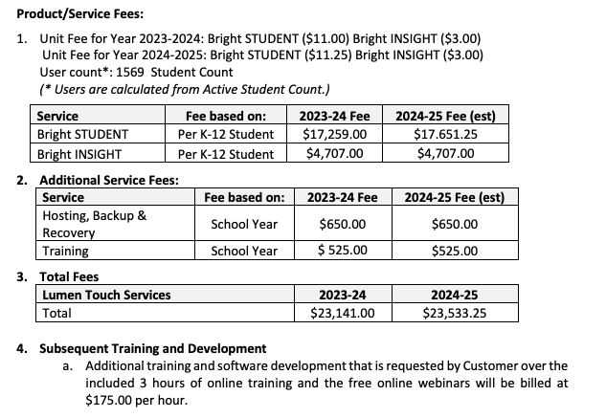

* These contracts are broken down into multiple year terms
* Everything in the **Service** column is 2 BTs - 1 for the first year and 1 for the second
  + Sometimes it is the same for both years and sometimes it is different
  + Annual up-front billing for each year
* Integration items map almost exactly to the the name of the item, with the exception:
  + Training = Bright - Training
  + Hosting = Lumin Hosting
* Processing #4 from above image as:
  + Additional training
  + Unit price
  + Billed in arrears
  + Every 6 months for the contract term (above be would be 4 occurrences to equal 2 years)
* For the 2nd year’s invoice, the invoice date needs to be 60 days before renewal date, which is one year after the execution date of the contract
  + **However, to do this, process as normal with the start date being the start date of the period.**
  + **Net 60 for the 2nd year, despite if the contract says otherwise**

**BPOS TO IGNORE THIS PART**

* + then go into the merchant app, find the 2nd year invoice
    - adjust the net payment terms to 60
    - Adjust the invoice date to 60 days prior to the original invoice date
    - New due date should = previous invoice date

**GG4L**

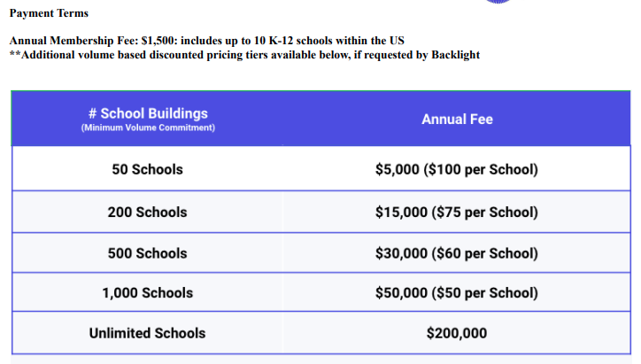

* These are annual upfront membership fees, outlined clearly in the payment terms section of the contract
* There is also a chart below that will outline additional school fees
  + Tiered BT
* Integration Item: Membership fee + cost
  + If there is no matching one then leave blank

**Districts**

* POs - process
* *Invoice Due Date should = contract term start date*

Net 60

1. Anything to ignore in contracts?
2. Specifics processing things the merchant has requested that may differ by contract (e.g. always back-date invoice date to final day of the month)
3. Default Service Term
   1. If None Listed, Ops Default is 1 Year
4. Default Net Payment Terms
   1. If None, Ops Default is 0
5. Default Billing Frequency
   1. If None Listed, Ops Default is Monthly
6. How do we handle taxes as a line item?
   1. If None Listed, Ops Default is every tax line item becomes a BT

### Events Processing (if necessary) *(Implementation/Success to fill)*

* Any important information on events billing

Integration Items Processing (if necessary)  
*(Implementation/Success to fill)*

* What are the instructions for assigning integration items?
* Example: All Statsig integrations items should be labeled as “Sales”
* Example: All “Pinata” integration items should be labeled as “Software Subscription Bundle” unless otherwise noted by Merchant

Post Processing Communications (if necessary)  
*(Implementation/Success to fill)*

* Does the Ops Team need to notify anyone on the team re: completion of processing batches in Implementation or Active phase?
* Who needs to be notified and when?
  + Example:
    - Who: Customer Success [Azmat Aziz] needs to be notified
    - Where: Messari internal merchant channel
    - When: contracts are processed [Merchant Phase: Active]

### Customer Information *(Implementation/Success to fill)*

* Any important information on specifics customers of this merchant
  + Special memo’s certain invoices require
  + Invoice changes due to merchant/customer relationship

### Feature Requests *(AE/Implementation/Success to fill)*

* Populating invoices with logo from different entities
  + GG4L acquired Lumen Torch. The are still billing Lumen Torch’s customers and asked if we could put that logo and billing address on the invoices
  + Customer management/confusion
  + Definitely a need to have but not urgent
* They track usage data in HS
  + They want to automatically pull usage data on a monthly basis from HS
  + Automated Process
  + Crawl, Walk, Run here
* Custom Fields per customer
  + Want Project ID and Sales Reppopulated on the customer level
  + Sales reps involved in collections
  + During implementation

### Rewatch Calls *(AE/Implementation/Success to fill)*

* Disco (10/14/24):
  + <https://tabs.rewatch.com/video/jzg6pqv5wvcdf12j-nicholas-gatti-and-robert-iskander-october-14-2024>
* Custom Demo and Proposal (10/15/24):
  + https://tabs.rewatch.com/video/7rfl1oxo88ll7bpx-gg4l-tabs-custom-demo-october-15-2024